Project Title: MyFirstWebAPI

🔧 Technology Stack:
.NET SDK: .NET 6.0
Language: C#
Framework: ASP.NET Core Web API
Tools: Swagger (Swashbuckle), Visual Studio Code / Terminal, Postman (optional)

📁 Folder Structure:
MyFirstWebAPI_Project/
├── Controllers/
│ └── StudentController.cs
├── Models/
│ └── Student.cs
├── Program.cs
├── MyFirstWebAPI.csproj

1️⃣ Program.cs
using Microsoft.AspNetCore.Builder;
using Microsoft.Extensions.DependencyInjection;
using Microsoft.Extensions.Hosting;
using Microsoft.OpenApi.Models;

var builder = WebApplication.CreateBuilder(args);
// Add services to the container.
builder.Services.AddControllers();
// 🔥 Add Swagger service here
builder.Services.AddSwaggerGen(c =>
{
c.SwaggerDoc("v1", new OpenApiInfo { Title = "MyFirstWebAPI", Version = "v1" });
});
var app = builder.Build();
// Configure the HTTP request pipeline.
if (app.Environment.IsDevelopment() || app.Environment.IsProduction())
{
// 🔥 Enable Swagger middleware
app.UseSwagger();
app.UseSwaggerUI(c =>
{
c.SwaggerEndpoint("/swagger/v1/swagger.json", "MyFirstWebAPI v1");
});
}
app.UseHttpsRedirection();
app.UseAuthorization();
app.MapControllers();
app.Run();

2️⃣ Student.cs (Model)
namespace MyFirstWebAPI.Models
{
public class Student
{
public int Id { get; set; }
public string Name { get; set; }
public string Course { get; set; }
public int Age { get; set; }
}
}

3️⃣ StudentController.cs (Controller)
using Microsoft.AspNetCore.Mvc;
using MyFirstWebAPI.Models;
using System.Collections.Generic;
using System.Linq;

namespace MyFirstWebAPI.Controllers
{
[ApiController]
[Route("[controller]")]
public class StudentController : ControllerBase
{
static List<Student> students = new List<Student>
{
new Student { Id = 1, Name = "John", Course = "Math", Age = 20 },
new Student { Id = 2, Name = "Alice", Course = "Science", Age = 22 }
};
[HttpGet]
public IActionResult GetAll()
{
return Ok(students);
}
[HttpGet("{id}")]
public IActionResult Get(int id)
{
var student = students.FirstOrDefault(s => s.Id == id);
if (student == null) return NotFound();
return Ok(student);
}
[HttpPost]
public IActionResult Create([FromBody] Student student)
{
student.Id = students.Count + 1;
students.Add(student);
return Ok(student);
}
[HttpPut("{id}")]
public IActionResult Update(int id, [FromBody] Student student)
{
var existing = students.FirstOrDefault(s => s.Id == id);
if (existing == null) return NotFound();
existing.Name = student.Name;
existing.Course = student.Course;
existing.Age = student.Age;
return Ok(existing);
}
[HttpDelete("{id}")]
public IActionResult Delete(int id)
{
var student = students.FirstOrDefault(s => s.Id == id);
if (student == null) return NotFound();
students.Remove(student);
return Ok("Deleted");
}
}
}

4️⃣ MyFirstWebAPI.csproj
<Project Sdk="Microsoft.NET.Sdk.Web">
<PropertyGroup>
<TargetFramework>net6.0</TargetFramework>
<Nullable>enable</Nullable>
<ImplicitUsings>enable</ImplicitUsings>
</PropertyGroup>
<ItemGroup>
<PackageReference Include="Microsoft.OpenApi" Version="1.6.0" />
<PackageReference Include="Swashbuckle.AspNetCore" Version="6.5.0" />
</ItemGroup>
</Project>

🧪 Testing with Swagger UI
Once you run:
dotnet run --project MyFirstWebAPI.csproj
Swagger UI is accessible at:
https://localhost:5001/swagger

✅ Output Screenshot to Paste:
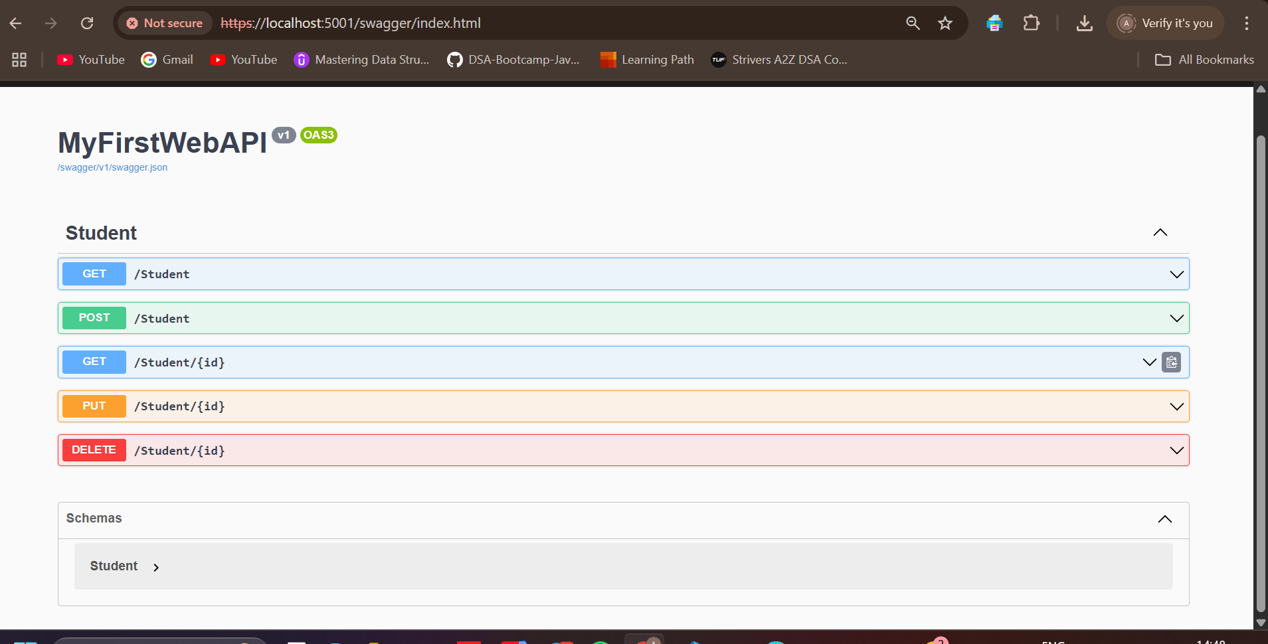

🧾Output (Copy-Paste this text):

🔹 POST /Student request:
{
"id": 3,
"name": "Charlie",
"course": "Mechanical"
}

🔹 Response:
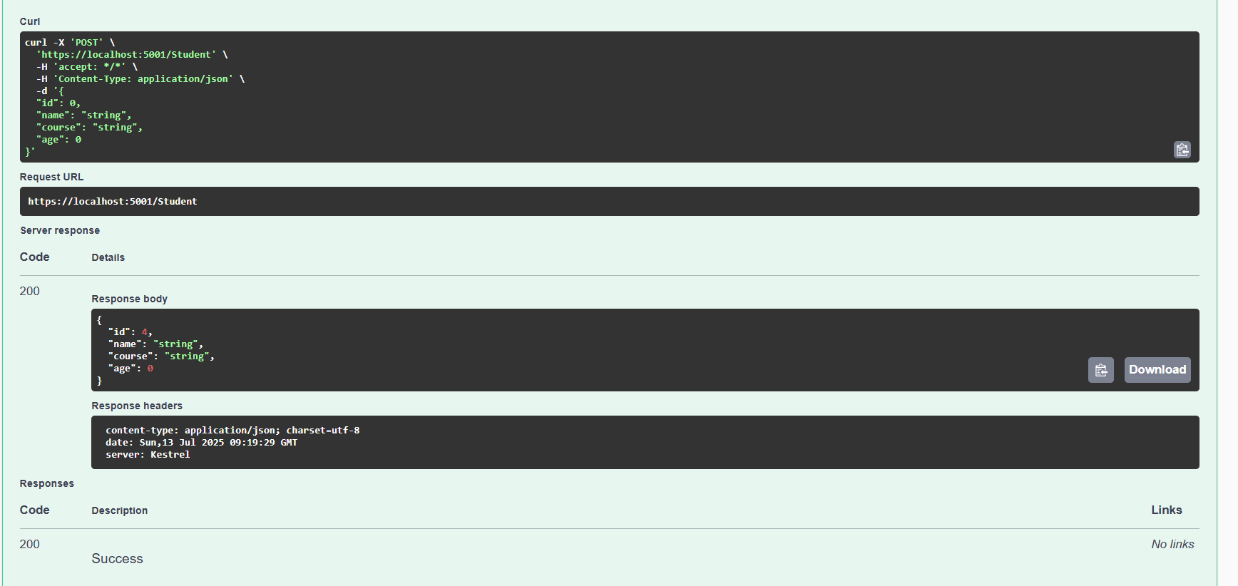

Terminal:
PS C:\Users\KIIT01\Downloads\MyFirstWebAPI_Project> dotnet clean MyFirstWebAPI.csproj
>> dotnet restore MyFirstWebAPI.csproj
>> dotnet build MyFirstWebAPI.csproj
>> dotnet run --project MyFirstWebAPI.csproj
>>

Build succeeded in 0.6s
Restore complete (0.4s)

Build succeeded in 0.9s
Restore complete (0.4s)
MyFirstWebAPI succeeded with 2 warning(s) (1.0s) → bin\Debug\net6.0\MyFirstWebAPI.dll
C:\Users\KIIT01\Downloads\MyFirstWebAPI_Project\Models\Student.cs(6,23): warning CS8618: Non-nullable property 'Name' must contain a non-null value when exiting constructor. Consider adding the 'required' modifier or declaring the property as nullable.
C:\Users\KIIT01\Downloads\MyFirstWebAPI_Project\Models\Student.cs(7,23): warning CS8618: Non-nullable property 'Course' must contain a non-null value when exiting constructor. Consider adding the 'required' modifier or declaring the property as nullable.

Build succeeded with 2 warning(s) in 2.0s
info: Microsoft.Hosting.Lifetime[14]
Now listening on: http://localhost:5000
info: Microsoft.Hosting.Lifetime[14]
Now listening on: https://localhost:5001
info: Microsoft.Hosting.Lifetime[0]
Application started. Press Ctrl+C to shut down.
info: Microsoft.Hosting.Lifetime[0]
Hosting environment: Production
info: Microsoft.Hosting.Lifetime[0]
Content root path: C:\Users\KIIT01\Downloads\MyFirstWebAPI_Project\
info: Microsoft.AspNetCore.Hosting.Diagnostics[1]
Request starting HTTP/2 GET https://localhost:5001/swagger - -
info: Microsoft.AspNetCore.Hosting.Diagnostics[2]
Request finished HTTP/2 GET https://localhost:5001/swagger - - - 301 0 - 158.5830ms
info: Microsoft.AspNetCore.Hosting.Diagnostics[1]
Request starting HTTP/2 GET https://localhost:5001/swagger/index.html - -
info: Microsoft.AspNetCore.Hosting.Diagnostics[2]
Request finished HTTP/2 GET https://localhost:5001/swagger/index.html - - - 200 - text/html;charset=utf-8 123.9090ms
info: Microsoft.AspNetCore.Hosting.Diagnostics[1]
Request starting HTTP/2 GET https://localhost:5001/swagger/swagger-ui.css - -
info: Microsoft.AspNetCore.Hosting.Diagnostics[1]
Request starting HTTP/2 GET https://localhost:5001/swagger/swagger-ui-bundle.js - -
info: Microsoft.AspNetCore.Hosting.Diagnostics[1]
Request starting HTTP/2 GET https://localhost:5001/swagger/swagger-ui-standalone-preset.js - -
info: Microsoft.AspNetCore.StaticFiles.StaticFileMiddleware[2]
Sending file. Request path: '/swagger-ui-standalone-preset.js'. Physical path: 'N/A'
info: Microsoft.AspNetCore.StaticFiles.StaticFileMiddleware[2]
Sending file. Request path: '/swagger-ui.css'. Physical path: 'N/A'
info: Microsoft.AspNetCore.Hosting.Diagnostics[2]
Request finished HTTP/2 GET https://localhost:5001/swagger/swagger-ui.css - - - 200 144929 text/css 117.8546ms
info: Microsoft.AspNetCore.Hosting.Diagnostics[2]
Request finished HTTP/2 GET https://localhost:5001/swagger/swagger-ui-standalone-preset.js - - - 200 312163 application/javascript 115.5134ms
info: Microsoft.AspNetCore.StaticFiles.StaticFileMiddleware[2]
Sending file. Request path: '/swagger-ui-bundle.js'. Physical path: 'N/A'
info: Microsoft.AspNetCore.Hosting.Diagnostics[2]
Request finished HTTP/2 GET https://localhost:5001/swagger/swagger-ui-bundle.js - - - 200 1061536 application/javascript 129.5872ms
info: Microsoft.AspNetCore.Hosting.Diagnostics[1]
Request starting HTTP/2 GET https://localhost:5001/swagger/v1/swagger.json - -
info: Microsoft.AspNetCore.Hosting.Diagnostics[1]
Request starting HTTP/2 GET https://localhost:5001/swagger/favicon-32x32.png - -
info: Microsoft.AspNetCore.StaticFiles.StaticFileMiddleware[2]
Sending file. Request path: '/favicon-32x32.png'. Physical path: 'N/A'
info: Microsoft.AspNetCore.Hosting.Diagnostics[2]
Request finished HTTP/2 GET https://localhost:5001/swagger/favicon-32x32.png - - - 200 628 image/png 0.4943ms
info: Microsoft.AspNetCore.Hosting.Diagnostics[2]
Request finished HTTP/2 GET https://localhost:5001/swagger/v1/swagger.json - - - 200 - application/json;charset=utf-8 188.7283ms
info: Microsoft.AspNetCore.Hosting.Diagnostics[1]
Request starting HTTP/2 GET https://localhost:5001/swagger/index.html - -
info: Microsoft.AspNetCore.Hosting.Diagnostics[2]
Request finished HTTP/2 GET https://localhost:5001/swagger/index.html - - - 200 - text/html;charset=utf-8 3.1464ms
info: Microsoft.AspNetCore.Hosting.Diagnostics[1]
Request starting HTTP/2 GET https://localhost:5001/swagger/favicon-32x32.png - -
info: Microsoft.AspNetCore.Hosting.Diagnostics[1]
Request starting HTTP/2 GET https://localhost:5001/swagger/v1/swagger.json - -
info: Microsoft.AspNetCore.StaticFiles.StaticFileMiddleware[2]
Sending file. Request path: '/favicon-32x32.png'. Physical path: 'N/A'
info: Microsoft.AspNetCore.Hosting.Diagnostics[2]
Request finished HTTP/2 GET https://localhost:5001/swagger/favicon-32x32.png - - - 200 628 image/png 0.5663ms
info: Microsoft.AspNetCore.Hosting.Diagnostics[2]
Request finished HTTP/2 GET https://localhost:5001/swagger/v1/swagger.json - - - 200 - application/json;charset=utf-8 3.0077ms
info: Microsoft.AspNetCore.Hosting.Diagnostics[1]
Request starting HTTP/2 POST https://localhost:5001/Student application/json 67
info: Microsoft.AspNetCore.Routing.EndpointMiddleware[0]
Executing endpoint 'MyFirstWebAPI.Controllers.StudentController.Create (MyFirstWebAPI)'
info: Microsoft.AspNetCore.Mvc.Infrastructure.ControllerActionInvoker[3]
Route matched with {action = "Create", controller = "Student"}. Executing controller action with signature Microsoft.AspNetCore.Mvc.IActionResult Create(MyFirstWebAPI.Models.Student) on controller MyFirstWebAPI.Controllers.StudentController (MyFirstWebAPI).
info: Microsoft.AspNetCore.Mvc.Infrastructure.ObjectResultExecutor[1]
Executing OkObjectResult, writing value of type 'MyFirstWebAPI.Models.Student'.
info: Microsoft.AspNetCore.Mvc.Infrastructure.ControllerActionInvoker[2]
Executed action MyFirstWebAPI.Controllers.StudentController.Create (MyFirstWebAPI) in 30.302ms
info: Microsoft.AspNetCore.Routing.EndpointMiddleware[1]
Executed endpoint 'MyFirstWebAPI.Controllers.StudentController.Create (MyFirstWebAPI)'
info: Microsoft.AspNetCore.Hosting.Diagnostics[2]
Request finished HTTP/2 POST https://localhost:5001/Student application/json 67 - 200 - application/json;+charset=utf-8 54.1150ms
info: Microsoft.AspNetCore.Hosting.Diagnostics[1]
Request starting HTTP/2 GET https://localhost:5001/Student/3 - -
info: Microsoft.AspNetCore.Routing.EndpointMiddleware[0]
Executing endpoint 'MyFirstWebAPI.Controllers.StudentController.Get (MyFirstWebAPI)'
info: Microsoft.AspNetCore.Mvc.Infrastructure.ControllerActionInvoker[3]
Route matched with {action = "Get", controller = "Student"}. Executing controller action with signature Microsoft.AspNetCore.Mvc.IActionResult Get(Int32) on controller MyFirstWebAPI.Controllers.StudentController (MyFirstWebAPI).
info: Microsoft.AspNetCore.Mvc.Infrastructure.ObjectResultExecutor[1]
Executing OkObjectResult, writing value of type 'MyFirstWebAPI.Models.Student'.
info: Microsoft.AspNetCore.Mvc.Infrastructure.ControllerActionInvoker[2]
Executed action MyFirstWebAPI.Controllers.StudentController.Get (MyFirstWebAPI) in 2.9214ms
info: Microsoft.AspNetCore.Routing.EndpointMiddleware[1]
Executed endpoint 'MyFirstWebAPI.Controllers.StudentController.Get (MyFirstWebAPI)'
info: Microsoft.AspNetCore.Hosting.Diagnostics[2]
Request finished HTTP/2 GET https://localhost:5001/Student/3 - - - 200 - application/json;+charset=utf-8 6.6875ms
info: Microsoft.AspNetCore.Hosting.Diagnostics[1]
Request starting HTTP/2 GET https://localhost:5001/swagger/index.html - -
info: Microsoft.AspNetCore.Hosting.Diagnostics[2]
Request finished HTTP/2 GET https://localhost:5001/swagger/index.html - - - 200 - text/html;charset=utf-8 0.9069ms
info: Microsoft.AspNetCore.Hosting.Diagnostics[1]
Request starting HTTP/2 GET https://localhost:5001/swagger/swagger-ui.css - -
info: Microsoft.AspNetCore.StaticFiles.StaticFileMiddleware[2]
Sending file. Request path: '/swagger-ui.css'. Physical path: 'N/A'
info: Microsoft.AspNetCore.Hosting.Diagnostics[2]
Request finished HTTP/2 GET https://localhost:5001/swagger/swagger-ui.css - - - 200 144929 text/css 1.7374ms
info: Microsoft.AspNetCore.Hosting.Diagnostics[1]
Request starting HTTP/2 GET https://localhost:5001/swagger/swagger-ui-bundle.js - -
info: Microsoft.AspNetCore.Hosting.Diagnostics[1]
Request starting HTTP/2 GET https://localhost:5001/swagger/swagger-ui-standalone-preset.js - -
info: Microsoft.AspNetCore.StaticFiles.StaticFileMiddleware[2]
Sending file. Request path: '/swagger-ui-standalone-preset.js'. Physical path: 'N/A'
info: Microsoft.AspNetCore.Hosting.Diagnostics[2]
Request finished HTTP/2 GET https://localhost:5001/swagger/swagger-ui-standalone-preset.js - - - 200 312163 application/javascript 3.2670ms
info: Microsoft.AspNetCore.StaticFiles.StaticFileMiddleware[2]
Sending file. Request path: '/swagger-ui-bundle.js'. Physical path: 'N/A'
info: Microsoft.AspNetCore.Hosting.Diagnostics[2]
Request finished HTTP/2 GET https://localhost:5001/swagger/swagger-ui-bundle.js - - - 200 1061536 application/javascript 14.6180ms
info: Microsoft.AspNetCore.Hosting.Diagnostics[1]
Request starting HTTP/2 GET https://localhost:5001/swagger/v1/swagger.json - -
info: Microsoft.AspNetCore.Hosting.Diagnostics[2]
Request finished HTTP/2 GET https://localhost:5001/swagger/v1/swagger.json - - - 200 - application/json;charset=utf-8 3.0063ms
info: Microsoft.AspNetCore.Hosting.Diagnostics[1]
Request starting HTTP/2 GET https://localhost:5001/swagger/favicon-32x32.png - -
info: Microsoft.AspNetCore.StaticFiles.StaticFileMiddleware[2]
Sending file. Request path: '/favicon-32x32.png'. Physical path: 'N/A'
info: Microsoft.AspNetCore.Hosting.Diagnostics[2]
Request finished HTTP/2 GET https://localhost:5001/swagger/favicon-32x32.png - - - 200 628 image/png 0.8656ms
info: Microsoft.AspNetCore.Hosting.Diagnostics[1]
Request starting HTTP/2 POST https://localhost:5001/Student application/json 67
info: Microsoft.AspNetCore.Routing.EndpointMiddleware[0]
Executing endpoint 'MyFirstWebAPI.Controllers.StudentController.Create (MyFirstWebAPI)'
info: Microsoft.AspNetCore.Mvc.Infrastructure.ControllerActionInvoker[3]
Route matched with {action = "Create", controller = "Student"}. Executing controller action with signature Microsoft.AspNetCore.Mvc.IActionResult Create(MyFirstWebAPI.Models.Student) on controller MyFirstWebAPI.Controllers.StudentController (MyFirstWebAPI).
info: Microsoft.AspNetCore.Mvc.Infrastructure.ObjectResultExecutor[1]
Executing OkObjectResult, writing value of type 'MyFirstWebAPI.Models.Student'.
info: Microsoft.AspNetCore.Mvc.Infrastructure.ControllerActionInvoker[2]
Executed action MyFirstWebAPI.Controllers.StudentController.Create (MyFirstWebAPI) in 1.5765ms
info: Microsoft.AspNetCore.Routing.EndpointMiddleware[1]
Executed endpoint 'MyFirstWebAPI.Controllers.StudentController.Create (MyFirstWebAPI)'
info: Microsoft.AspNetCore.Hosting.Diagnostics[2]
Request finished HTTP/2 POST https://localhost:5001/Student application/json 67 - 200 - application/json;+charset=utf-8 4.2933ms
info: Microsoft.Hosting.Lifetime[0]
Application is shutting down...
PS C:\Users\KIIT01\Downloads\MyFirstWebAPI_Project>

Conclusion
This project showcases the implementation of a RESTful Web API using .NET 6 with proper routing, CRUD operations, and Swagger documentation. It provides a foundational understanding of API development using ASP.NET Core.

